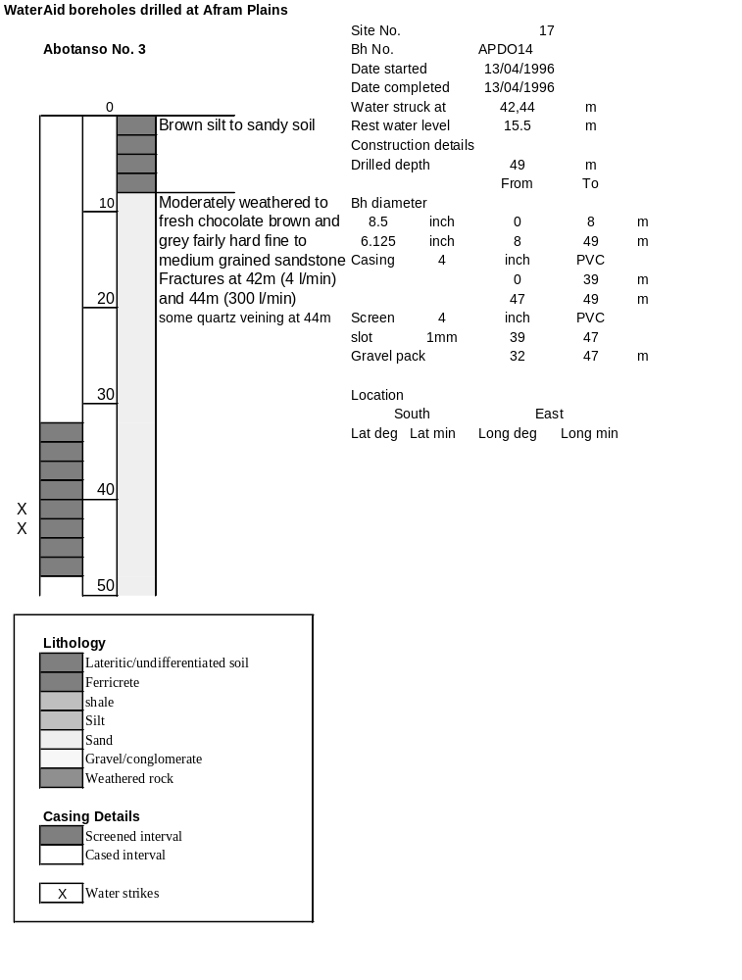

Ghana | Test pumping
Borehole No. |  | APDO14
Hole No |  | 17
Village |  | Abotanso No. 3
Date |  | 20/04/1996
Point above GL |  | 0.5 | m
Pump depth |  | 38 | m
SWL |  | 16 | m
Start Time |  | 08:10
Drawdown test |  |  |  |  | Recovery test
time | pwl (m) | Q l/min | dd | sc | Time | wl (m) | s' | t/t'
0.00 | 16.00 | 150.00 | 0.00 |  | 0.00 | 24.40 | 8.40
1.00 | 16.75 | 150.00 | 0.75 | 200.00 | 1.00 | 23.75 | 7.75 | 181.00
2.00 | 16.92 | 150.00 | 0.92 | 163.04 | 2.00 | 23.62 | 7.62 | 91.00
3.00 | 17.05 | 150.00 | 1.05 | 142.86 | 3.00 | 23.50 | 7.50 | 61.00
4.00 | 17.17 | 150.00 | 1.17 | 128.21 | 4.00 | 23.40 | 7.40 | 46.00
5.00 | 17.25 | 150.00 | 1.25 | 120.00 | 5.00 | 23.31 | 7.31 | 37.00
6.00 | 17.40 | 150.00 | 1.40 | 107.14 | 6.00 | 23.21 | 7.21 | 31.00
7.00 | 17.50 | 150.00 | 1.50 | 100.00 | 7.00 | 23.13 | 7.13 | 26.71
8.00 | 17.59 | 150.00 | 1.59 | 94.34 | 8.00 | 23.05 | 7.05 | 23.50
9.00 | 17.68 | 150.00 | 1.68 | 89.29 | 9.00 | 23.02 | 7.02 | 21.00
10.00 | 17.78 | 150.00 | 1.78 | 84.27 | 10.00 | 22.95 | 6.95 | 19.00
11.00 | 17.87 | 150.00 | 1.87 | 80.21 | 12.00 | 22.75 | 6.75 | 16.00
12.00 | 17.96 | 150.00 | 1.96 | 76.53 | 14.00 | 22.62 | 6.62 | 13.86
13.00 | 18.04 | 150.00 | 2.04 | 73.53 | 16.00 | 22.50 | 6.50 | 12.25
14.00 | 18.12 | 150.00 | 2.12 | 70.75 | 18.00 | 22.37 | 6.37 | 11.00
15.00 | 18.20 | 150.00 | 2.20 | 68.18 | 20.00 | 22.25 | 6.25 | 10.00
16.00 | 18.26 | 150.00 | 2.26 | 66.37 | 22.00 | 22.15 | 6.15 | 9.18
17.00 | 18.34 | 150.00 | 2.34 | 64.10 | 24.00 | 22.06 | 6.06 | 8.50
18.00 | 18.41 | 150.00 | 2.41 | 62.24 | 26.00 | 21.93 | 5.93 | 7.92
19.00 | 18.49 | 150.00 | 2.49 | 60.24 | 28.00 | 21.84 | 5.84 | 7.43
20.00 | 18.55 | 150.00 | 2.55 | 58.82 | 30.00 | 21.75 | 5.75 | 7.00
22.00 | 18.70 | 150.00 | 2.70 | 55.56 | 35.00 | 21.52 | 5.52 | 6.14
24.00 | 18.83 | 150.00 | 2.83 | 53.00 | 40.00 | 21.34 | 5.34 | 5.50
26.00 | 18.96 | 150.00 | 2.96 | 50.68 | 45.00 | 21.13 | 5.13 | 5.00
28.00 | 19.08 | 150.00 | 3.08 | 48.70 | 50.00 | 20.97 | 4.97 | 4.60
30.00 | 19.20 | 150.00 | 3.20 | 46.88 | 60.00 | 20.65 | 4.65 | 4.00
35.00 | 19.50 | 150.00 | 3.50 | 42.86 | 70.00 | 20.36 | 4.36 | 3.57
40.00 | 19.77 | 150.00 | 3.77 | 39.79 | 80.00 | 20.11 | 4.11 | 3.25
45.00 | 20.03 | 150.00 | 4.03 | 37.22 | 90.00 | 19.90 | 3.90 | 3.00
50.00 | 20.27 | 150.00 | 4.27 | 35.13 | 100.00 | 19.72 | 3.72 | 2.80
55.00 | 20.52 | 150.00 | 4.52 | 33.19 | 110.00 | 19.53 | 3.53 | 2.64
60.00 | 20.73 | 150.00 | 4.73 | 31.71 | 120.00 | 19.37 | 3.37 | 2.50
70.00 | 21.16 | 150.00 | 5.16 | 29.07
80.00 | 21.56 | 150.00 | 5.56 | 26.98
90.00 | 21.94 | 150.00 | 5.94 | 25.25
100.00 | 22.30 | 150.00 | 6.30 | 23.81
110.00 | 22.61 | 150.00 | 6.61 | 22.69
120.00 | 22.92 | 150.00 | 6.92 | 21.68
130.00 | 23.20 | 150.00 | 7.20 | 20.83
140.00 | 23.50 | 150.00 | 7.50 | 20.00
160.00 | 23.98 | 150.00 | 7.98 | 18.80
180.00 | 24.40 | 150.00 | 8.40 | 17.86

